Jan 29

Mike’s first run:
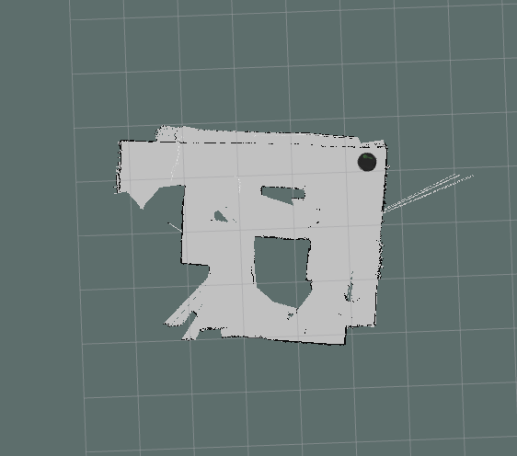
problems:
- ends up going in loops
- got stuck in corner
- side hit on obstacles
- in blind spot trouble
- tape the wires
- add code to save map
- need to start gmapping for \scan topic to broadcast

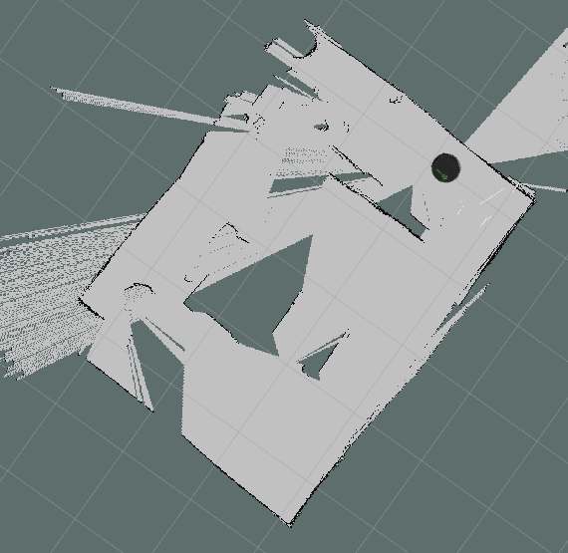

2:57 duration. Tried to resolve corners a bit better

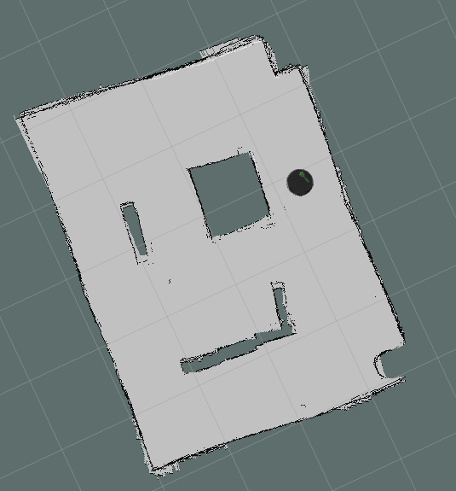

8 min, about 4 min in the map is pretty set. We added 360 every 10 seconds
the 360 took roughly 10seconds to execute per.
360 did not really do 360, more like.. 300 deg.

